Polygon–Organic Open Shapes
# Source: AI Source: Provided by: [Data Path: Persons Table -> ID Column: 1, Name_En Column: Motasem Essam] -> From: [ChatGPT] on [7/25/2026]
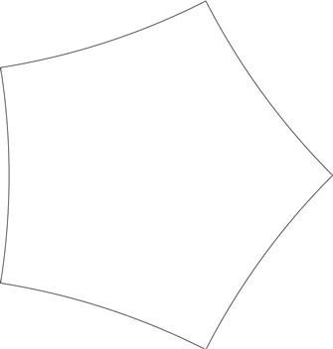
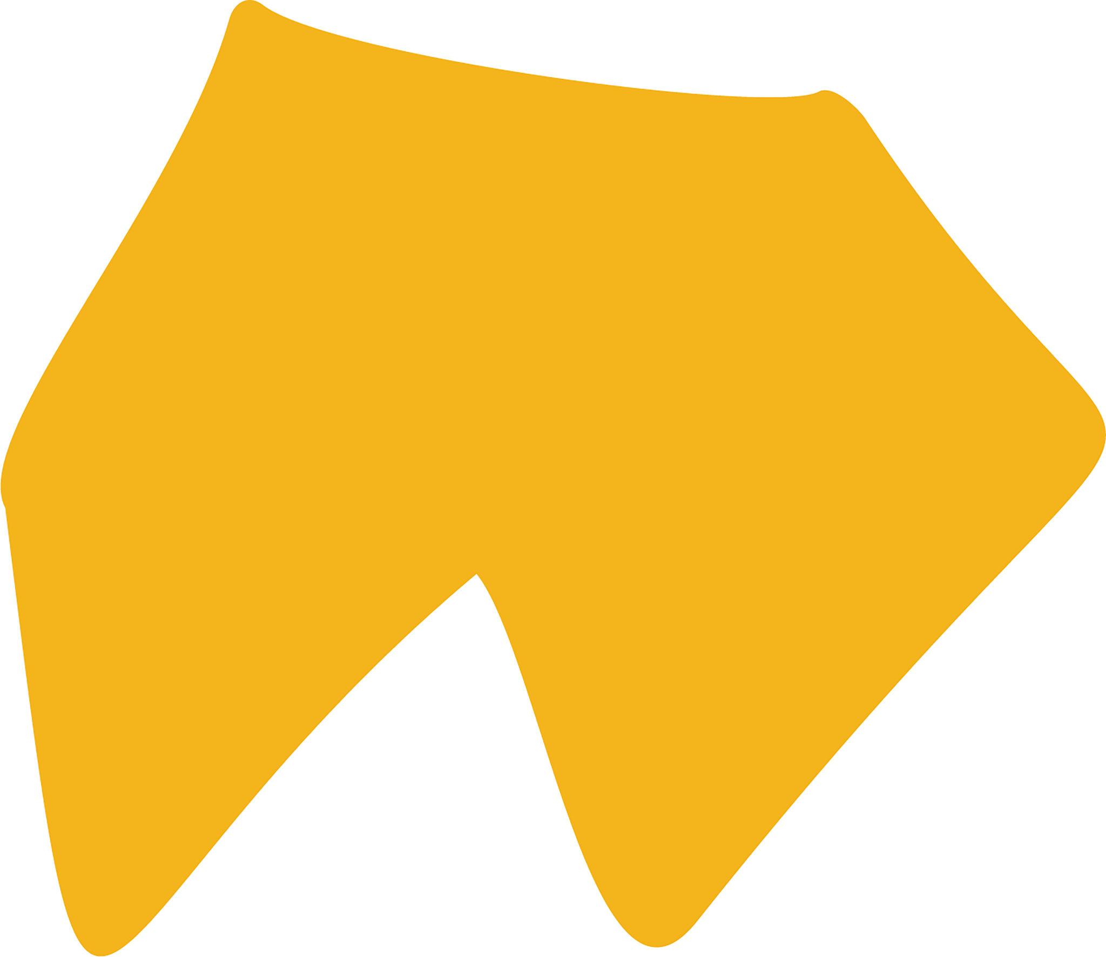
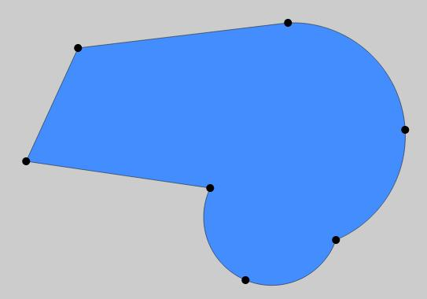
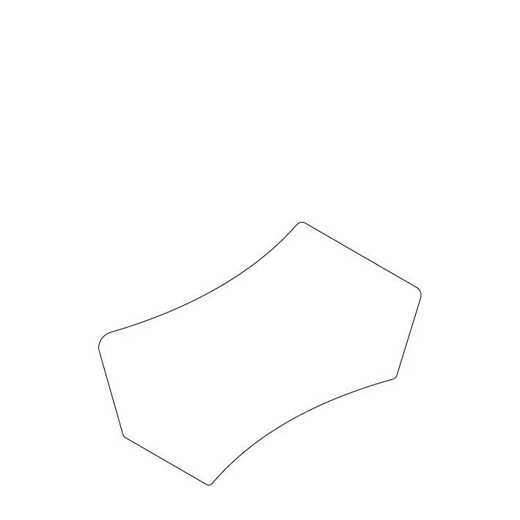

Definition
# Source: AI Source: Provided by: [Data Path: Persons Table -> ID Column: 1, Name_En Column: Motasem Essam] -> From: [ChatGPT] on [7/25/2026]
A Polygon–Organic Open Shape is an open mixed shape that combines straight polygonal segments with irregular, natural-looking curved portions.
$$\boxed{\text{Polygon–Organic Open Shape}=\text{Polygonal Segments}+\text{Organic Curves}+\text{Open Boundary}}$$
The shape is open because its boundary or path does not completely return to its starting point.

Characteristics
# Source: AI Source: Provided by: [Data Path: Persons Table -> ID Column: 1, Name_En Column: Motasem Essam] -> From: [ChatGPT] on [7/25/2026]
A Polygon–Organic Open Shape:
- Is open.
- Contains one or more straight polygonal segments.
- Contains one or more organic curved portions.
- Combines angular and naturally flowing geometry.
- Has at least two endpoints.
- Does not enclose an area by itself.
- Usually has irregular curvature in its organic portions.
- May contain sharp polygonal corners.
- May be symmetric or asymmetric.
- Can resemble natural objects or freely designed forms.

Types of Polygon–Organic Open Shapes

1. Simple Polygon–Organic Open Shape
# Source: AI Source: Provided by: [Data Path: Persons Table -> ID Column: 1, Name_En Column: Motasem Essam] -> From: [ChatGPT] on [7/25/2026]
A basic open path combining a few straight polygonal segments with a simple organic curve.
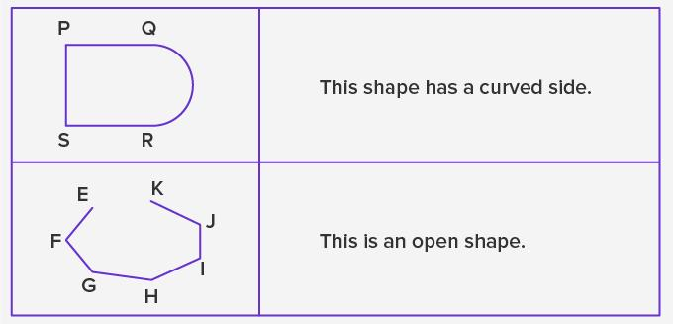
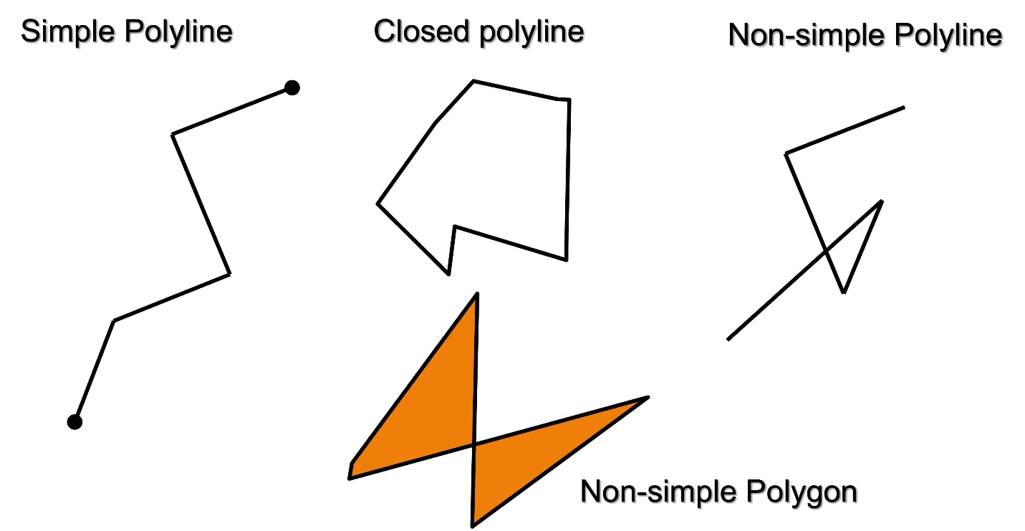

2. Irregular Polygon–Organic Open Shape
# Source: AI Source: Provided by: [Data Path: Persons Table -> ID Column: 1, Name_En Column: Motasem Essam] -> From: [ChatGPT] on [7/25/2026]
An open shape with irregular polygonal segments and irregular organic curvature.
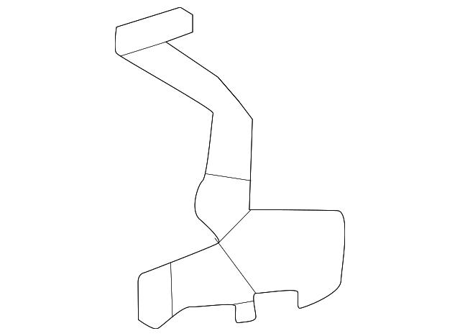
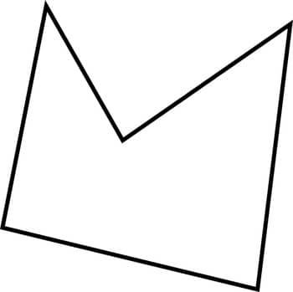
This is one of the broadest forms in this category.

3. Natural Polygon–Organic Open Shape
# Source: AI Source: Provided by: [Data Path: Persons Table -> ID Column: 1, Name_En Column: Motasem Essam] -> From: [ChatGPT] on [7/25/2026]
A naturally occurring open form that combines approximately straight/angular portions with organic curves.
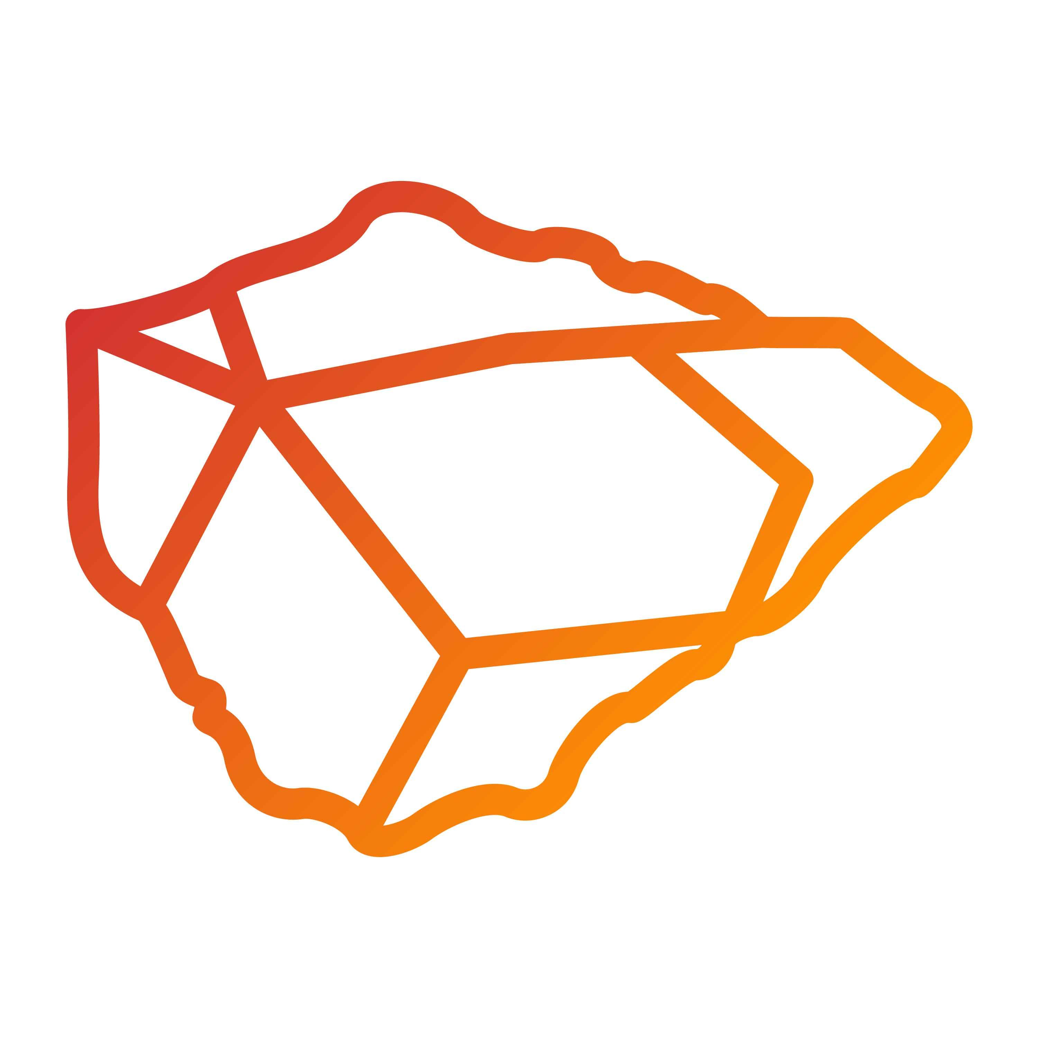
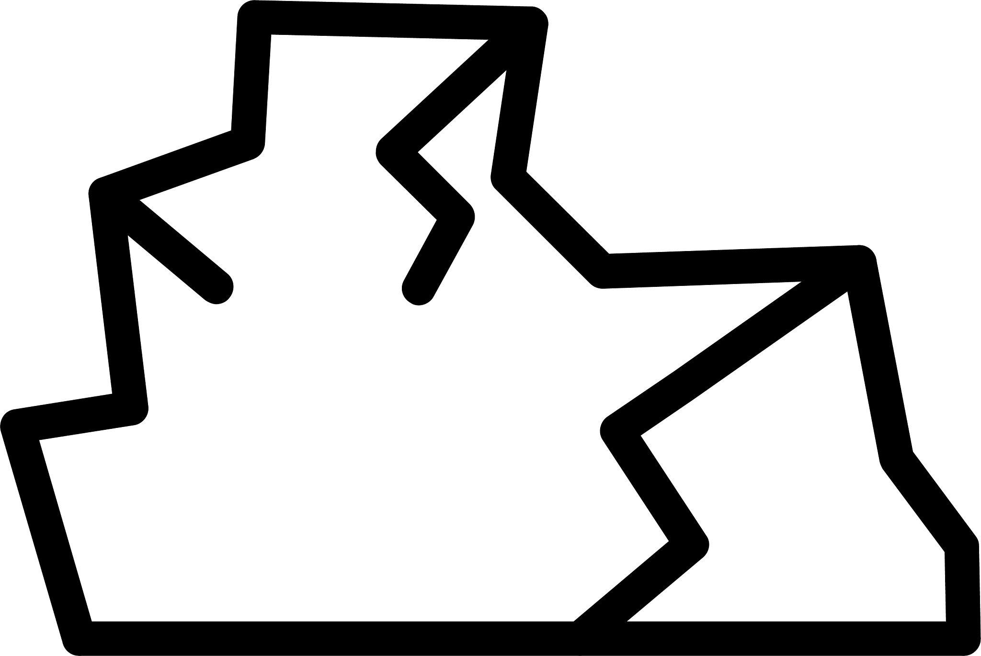
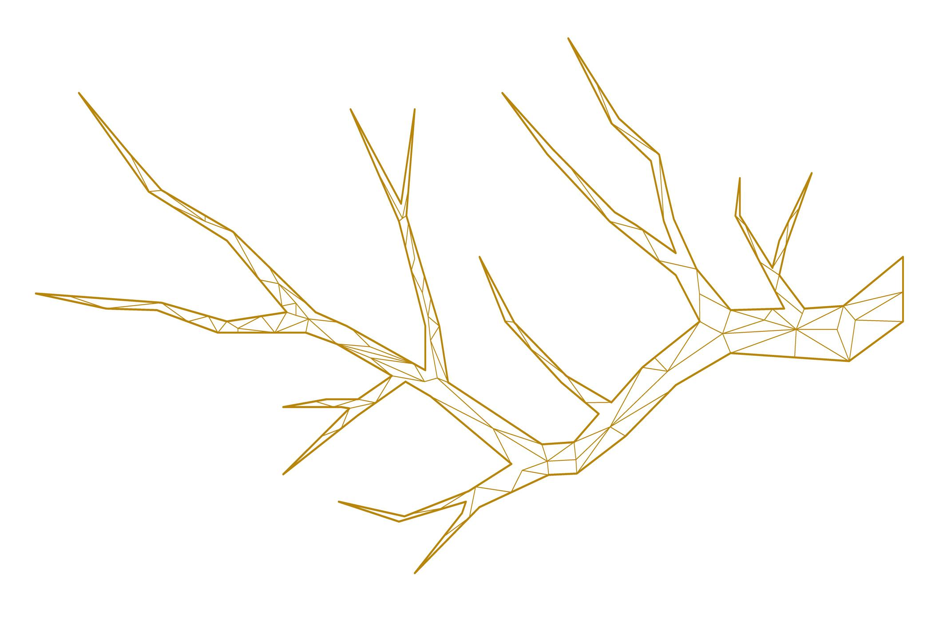
Examples can include portions of natural rock formations, branches, leaves, or landscape boundaries.

4. Branch-Like Polygon–Organic Open Shape
# Source: AI Source: Provided by: [Data Path: Persons Table -> ID Column: 1, Name_En Column: Motasem Essam] -> From: [ChatGPT] on [7/25/2026]
A path combining angular segments with curves resembling branches.
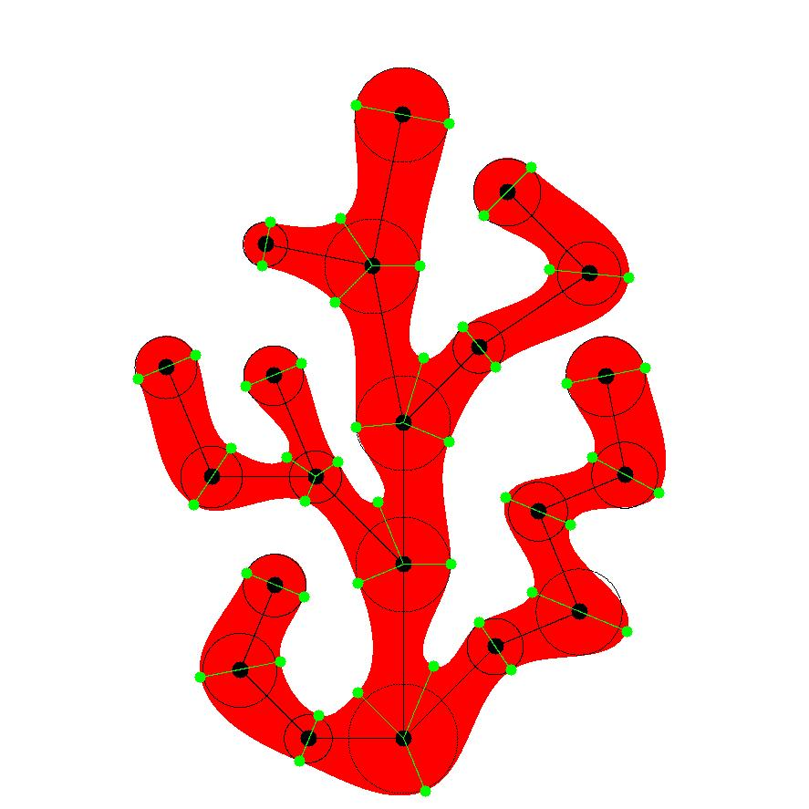
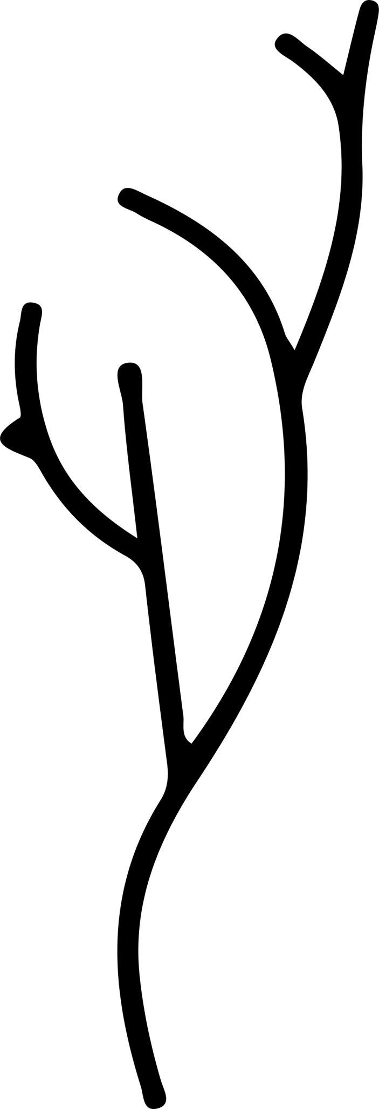
The organic portions give the shape its natural appearance.

5. Leaf-Like Polygon–Organic Open Shape
# Source: AI Source: Provided by: [Data Path: Persons Table -> ID Column: 1, Name_En Column: Motasem Essam] -> From: [ChatGPT] on [7/25/2026]
A partially represented leaf-like path containing both angular and flowing curved portions.
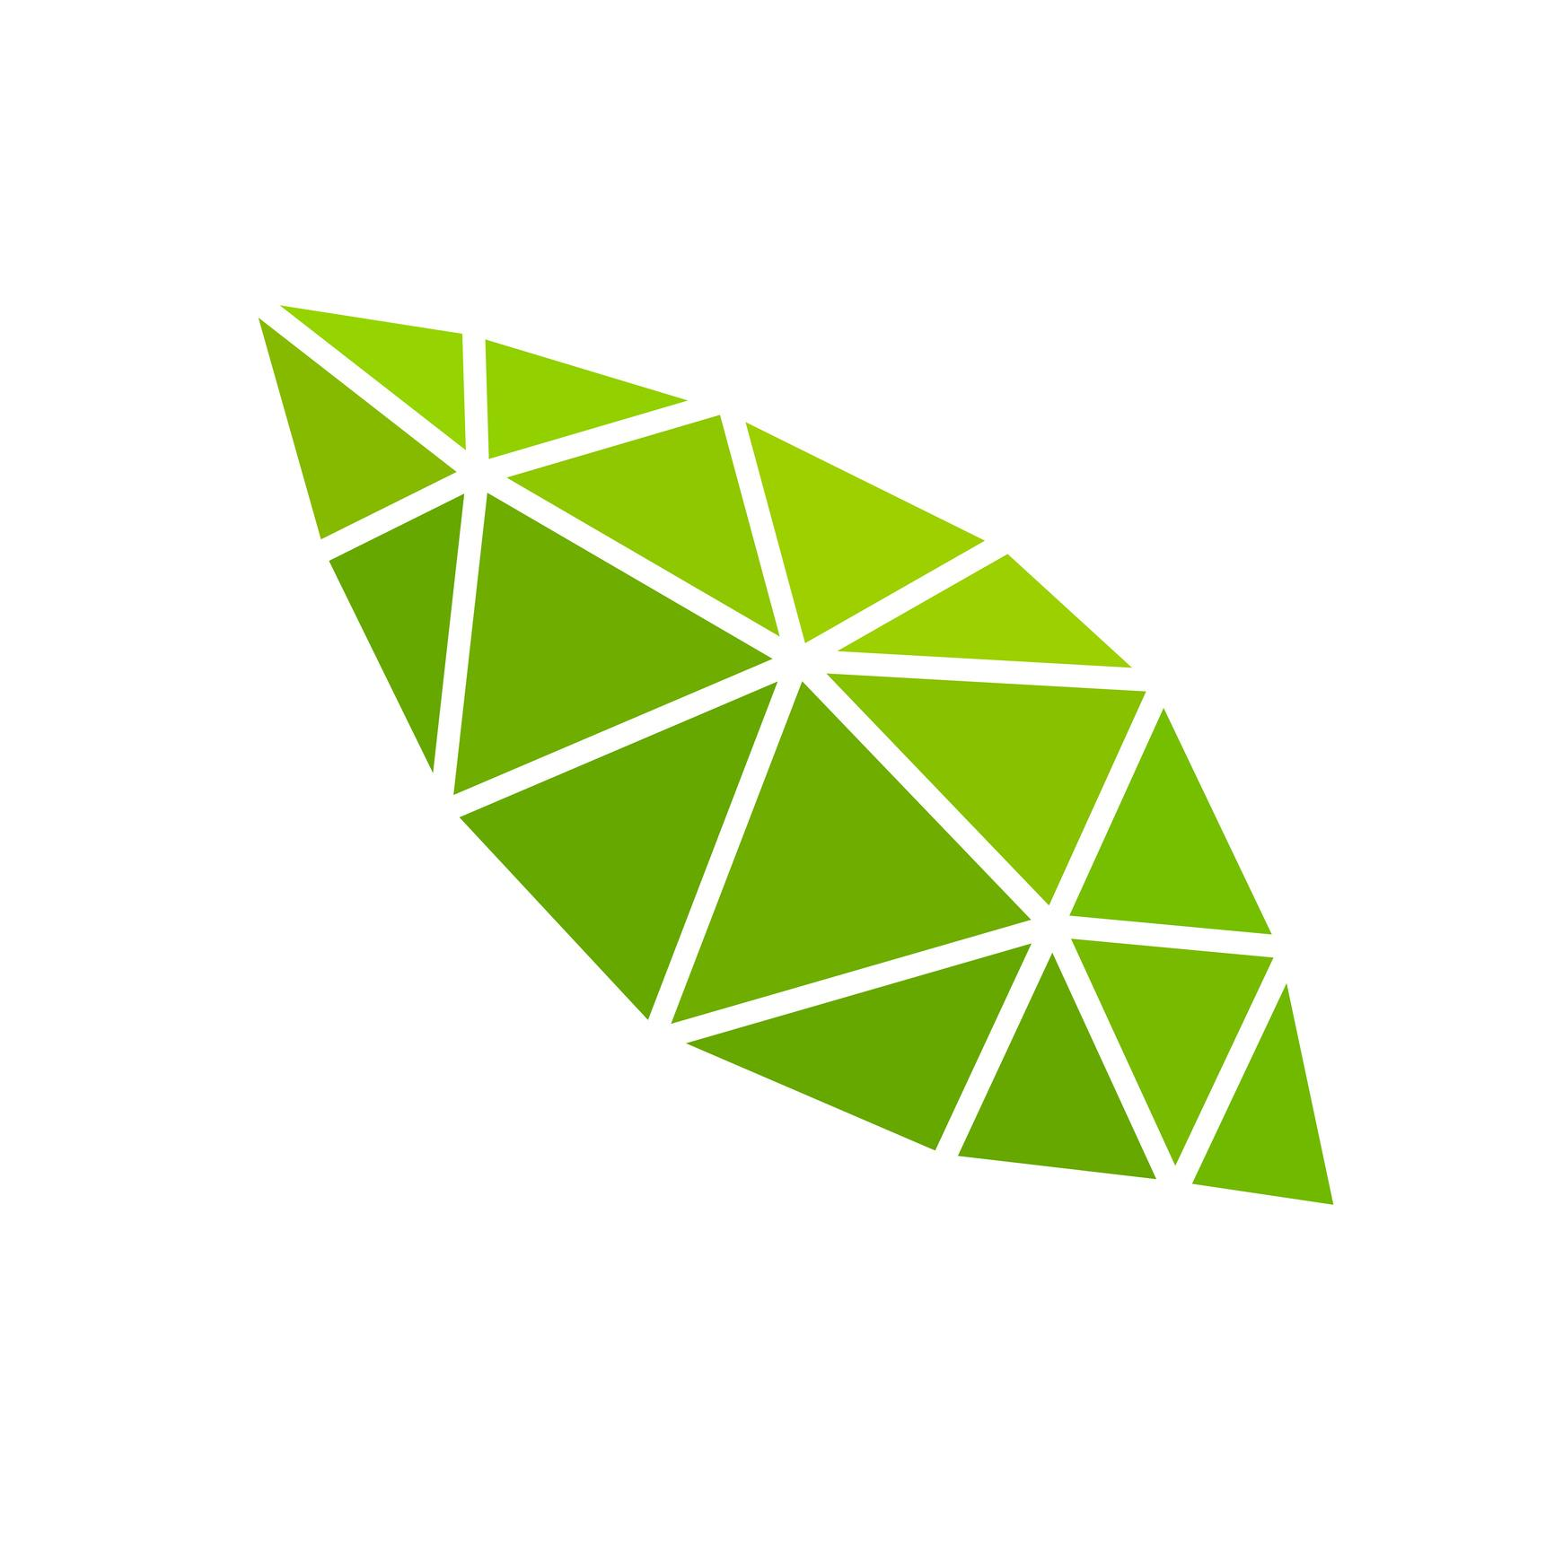

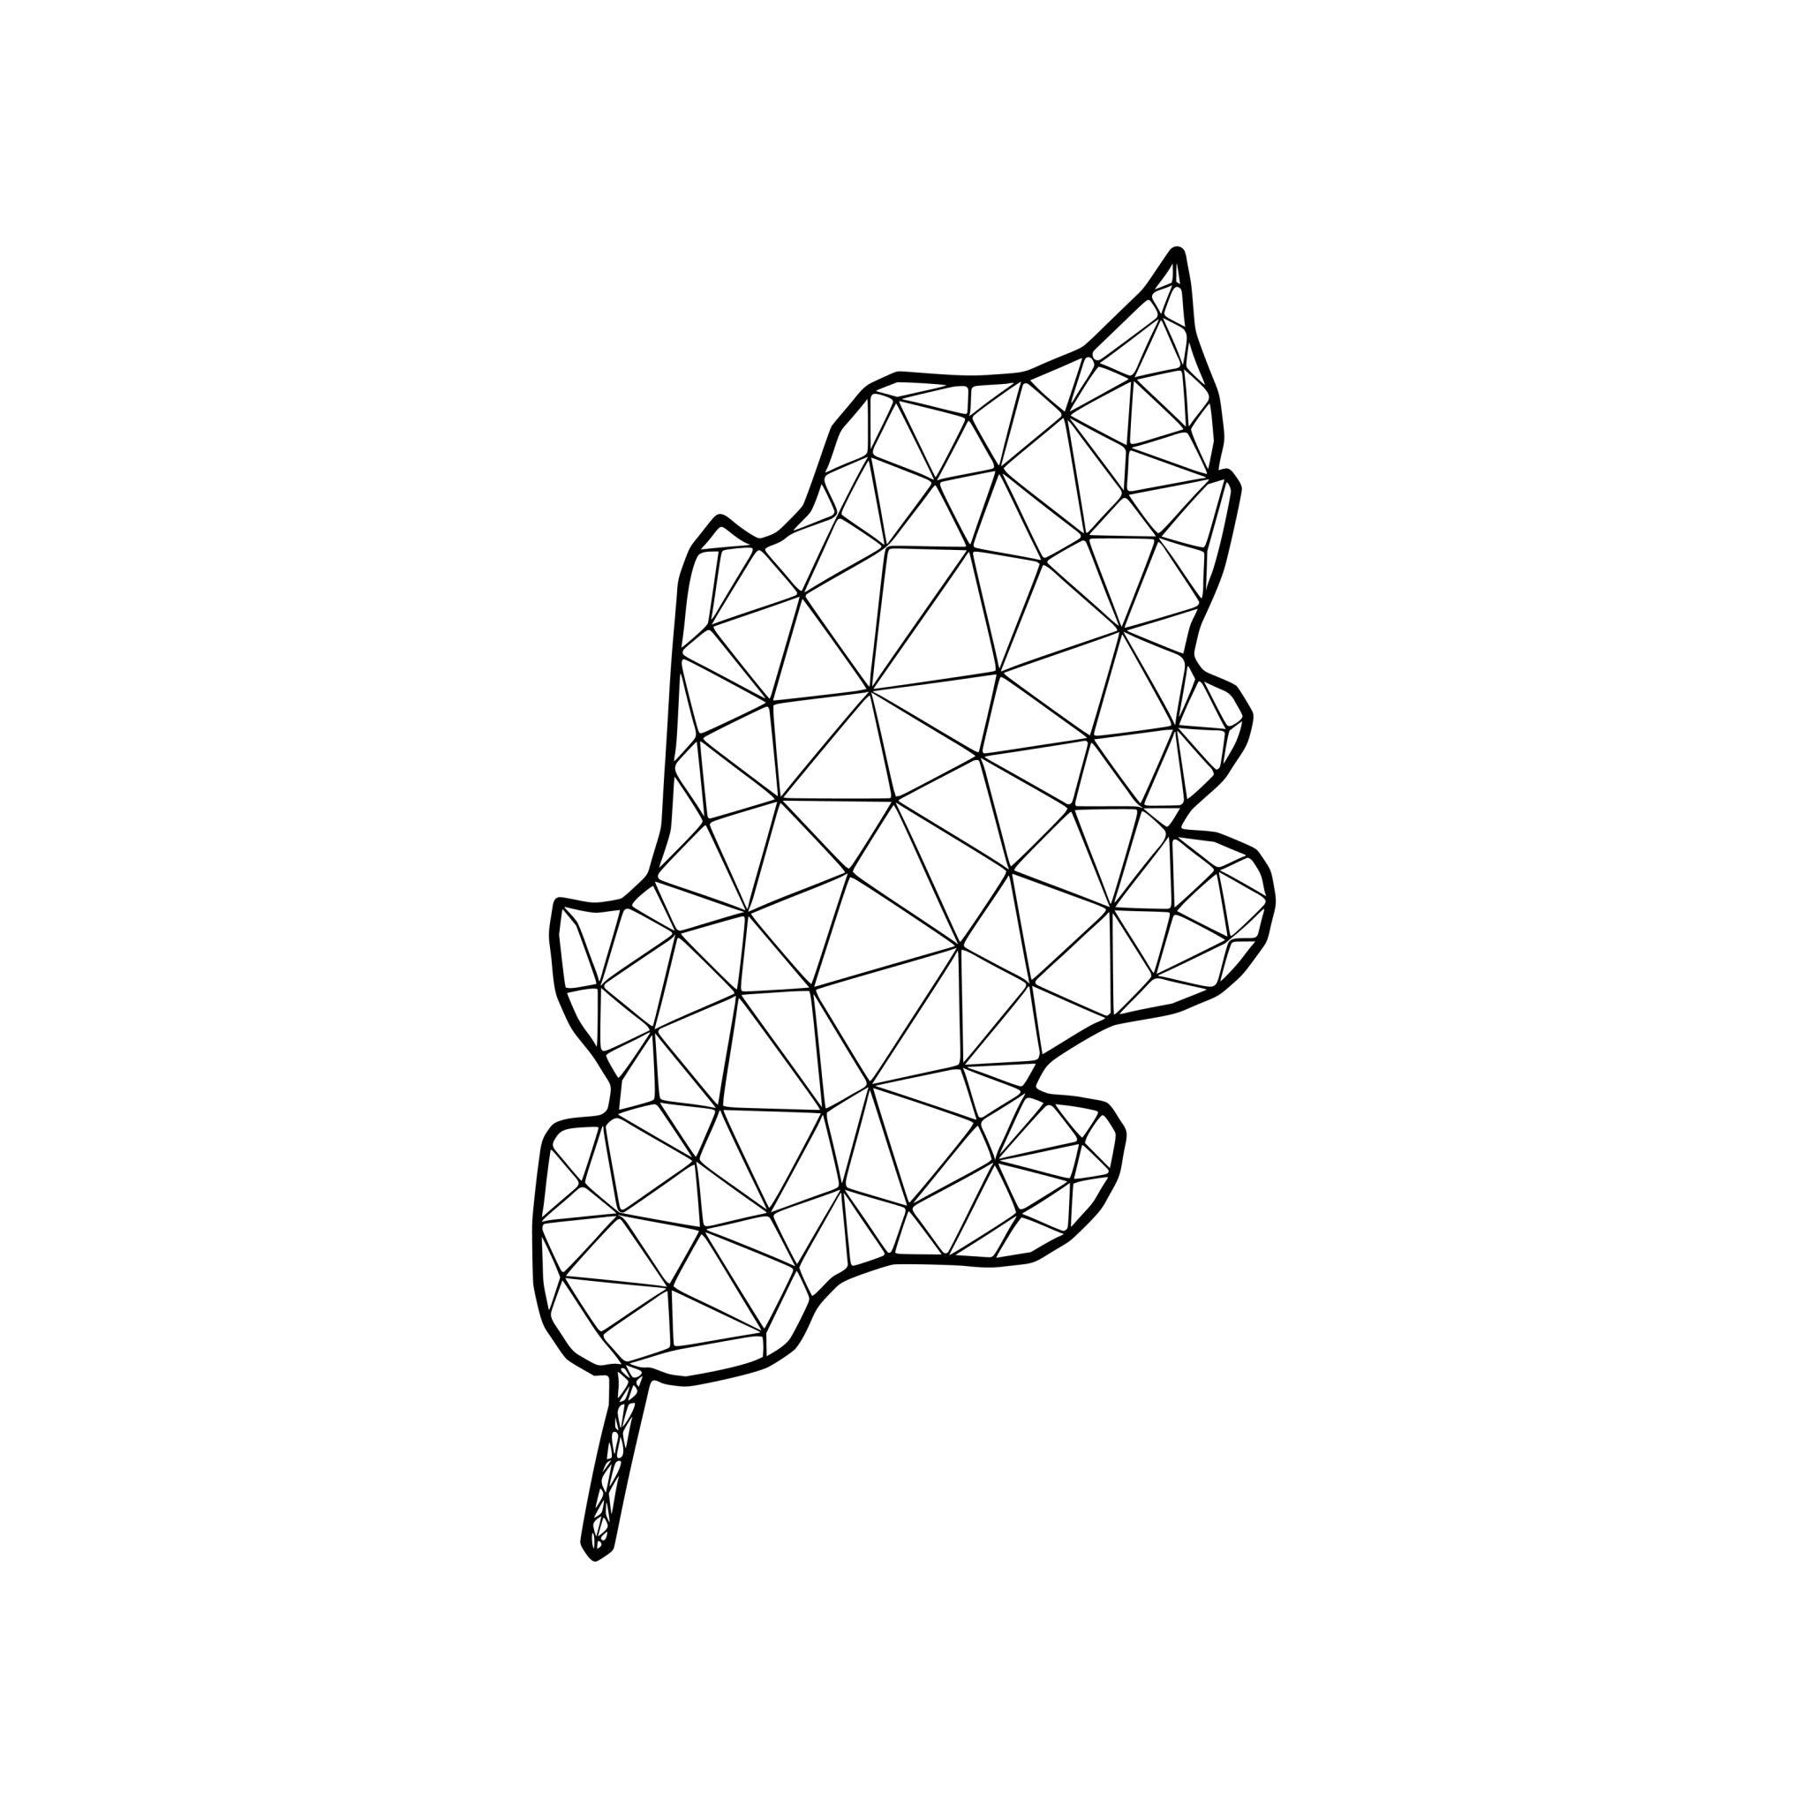


6. Wavy Polygon–Organic Open Shape
# Source: AI Source: Provided by: [Data Path: Persons Table -> ID Column: 1, Name_En Column: Motasem Essam] -> From: [ChatGPT] on [7/25/2026]
A polygonal open path combined with an organic curve containing waves or undulations.
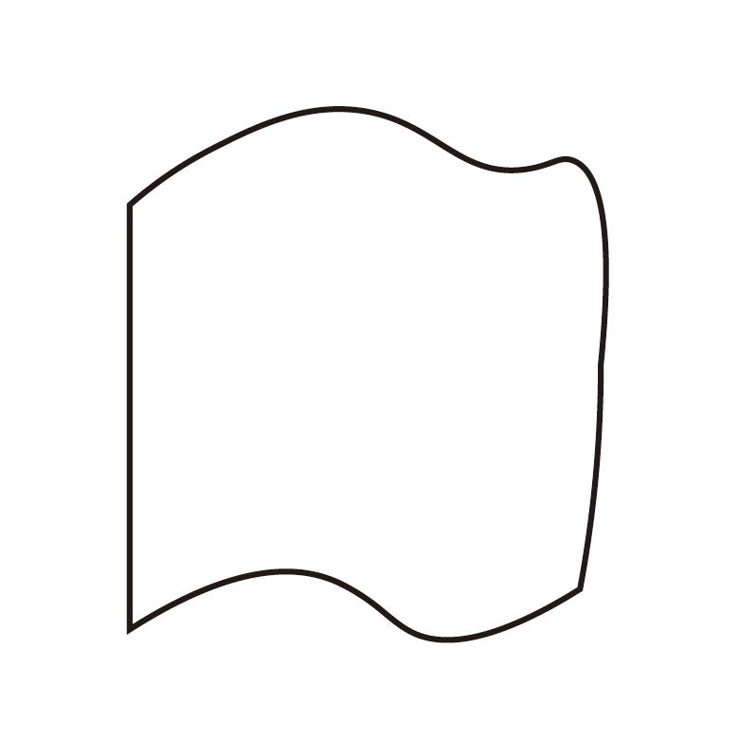
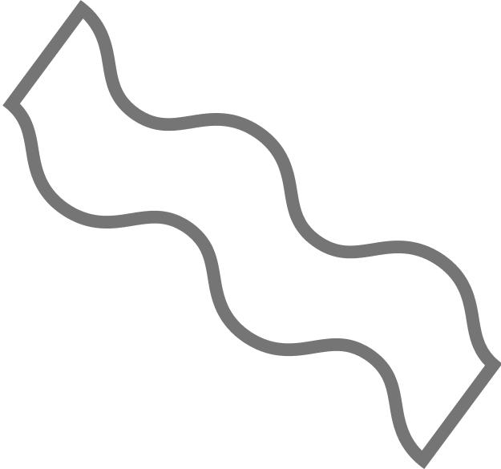
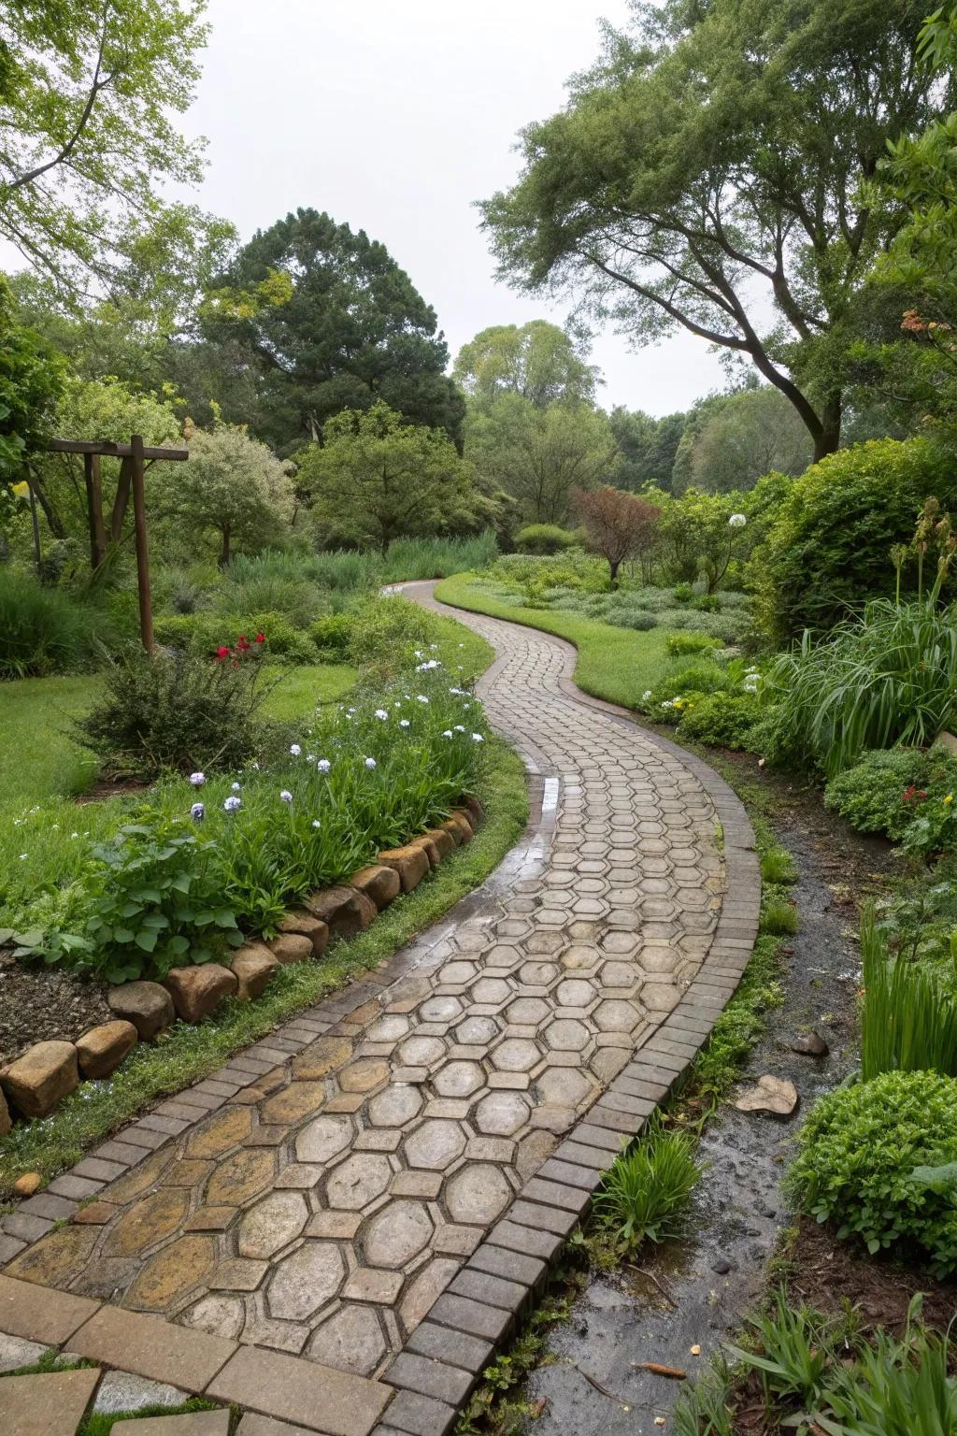

7. Smooth Polygon–Organic Open Shape
# Source: AI Source: Provided by: [Data Path: Persons Table -> ID Column: 1, Name_En Column: Motasem Essam] -> From: [ChatGPT] on [7/25/2026]
The polygonal sections connect to smoothly flowing organic curves.
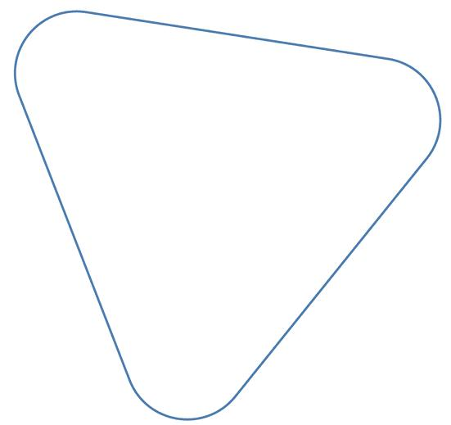
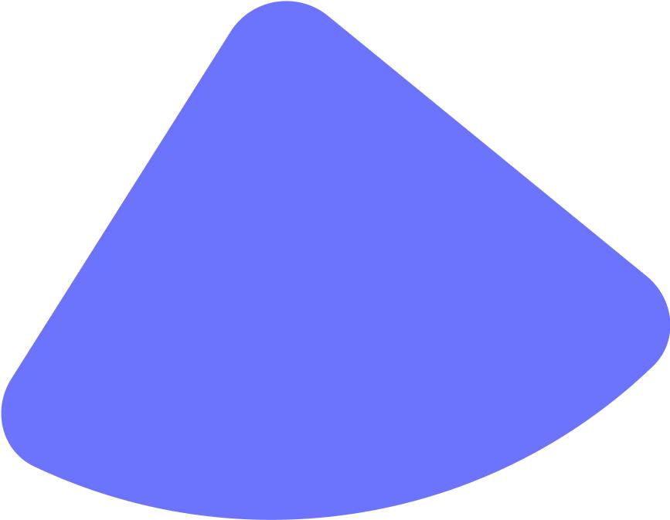

8. Asymmetric Polygon–Organic Open Shape
# Source: AI Source: Provided by: [Data Path: Persons Table -> ID Column: 1, Name_En Column: Motasem Essam] -> From: [ChatGPT] on [7/25/2026]
An open mixed shape with no recognizable symmetry.
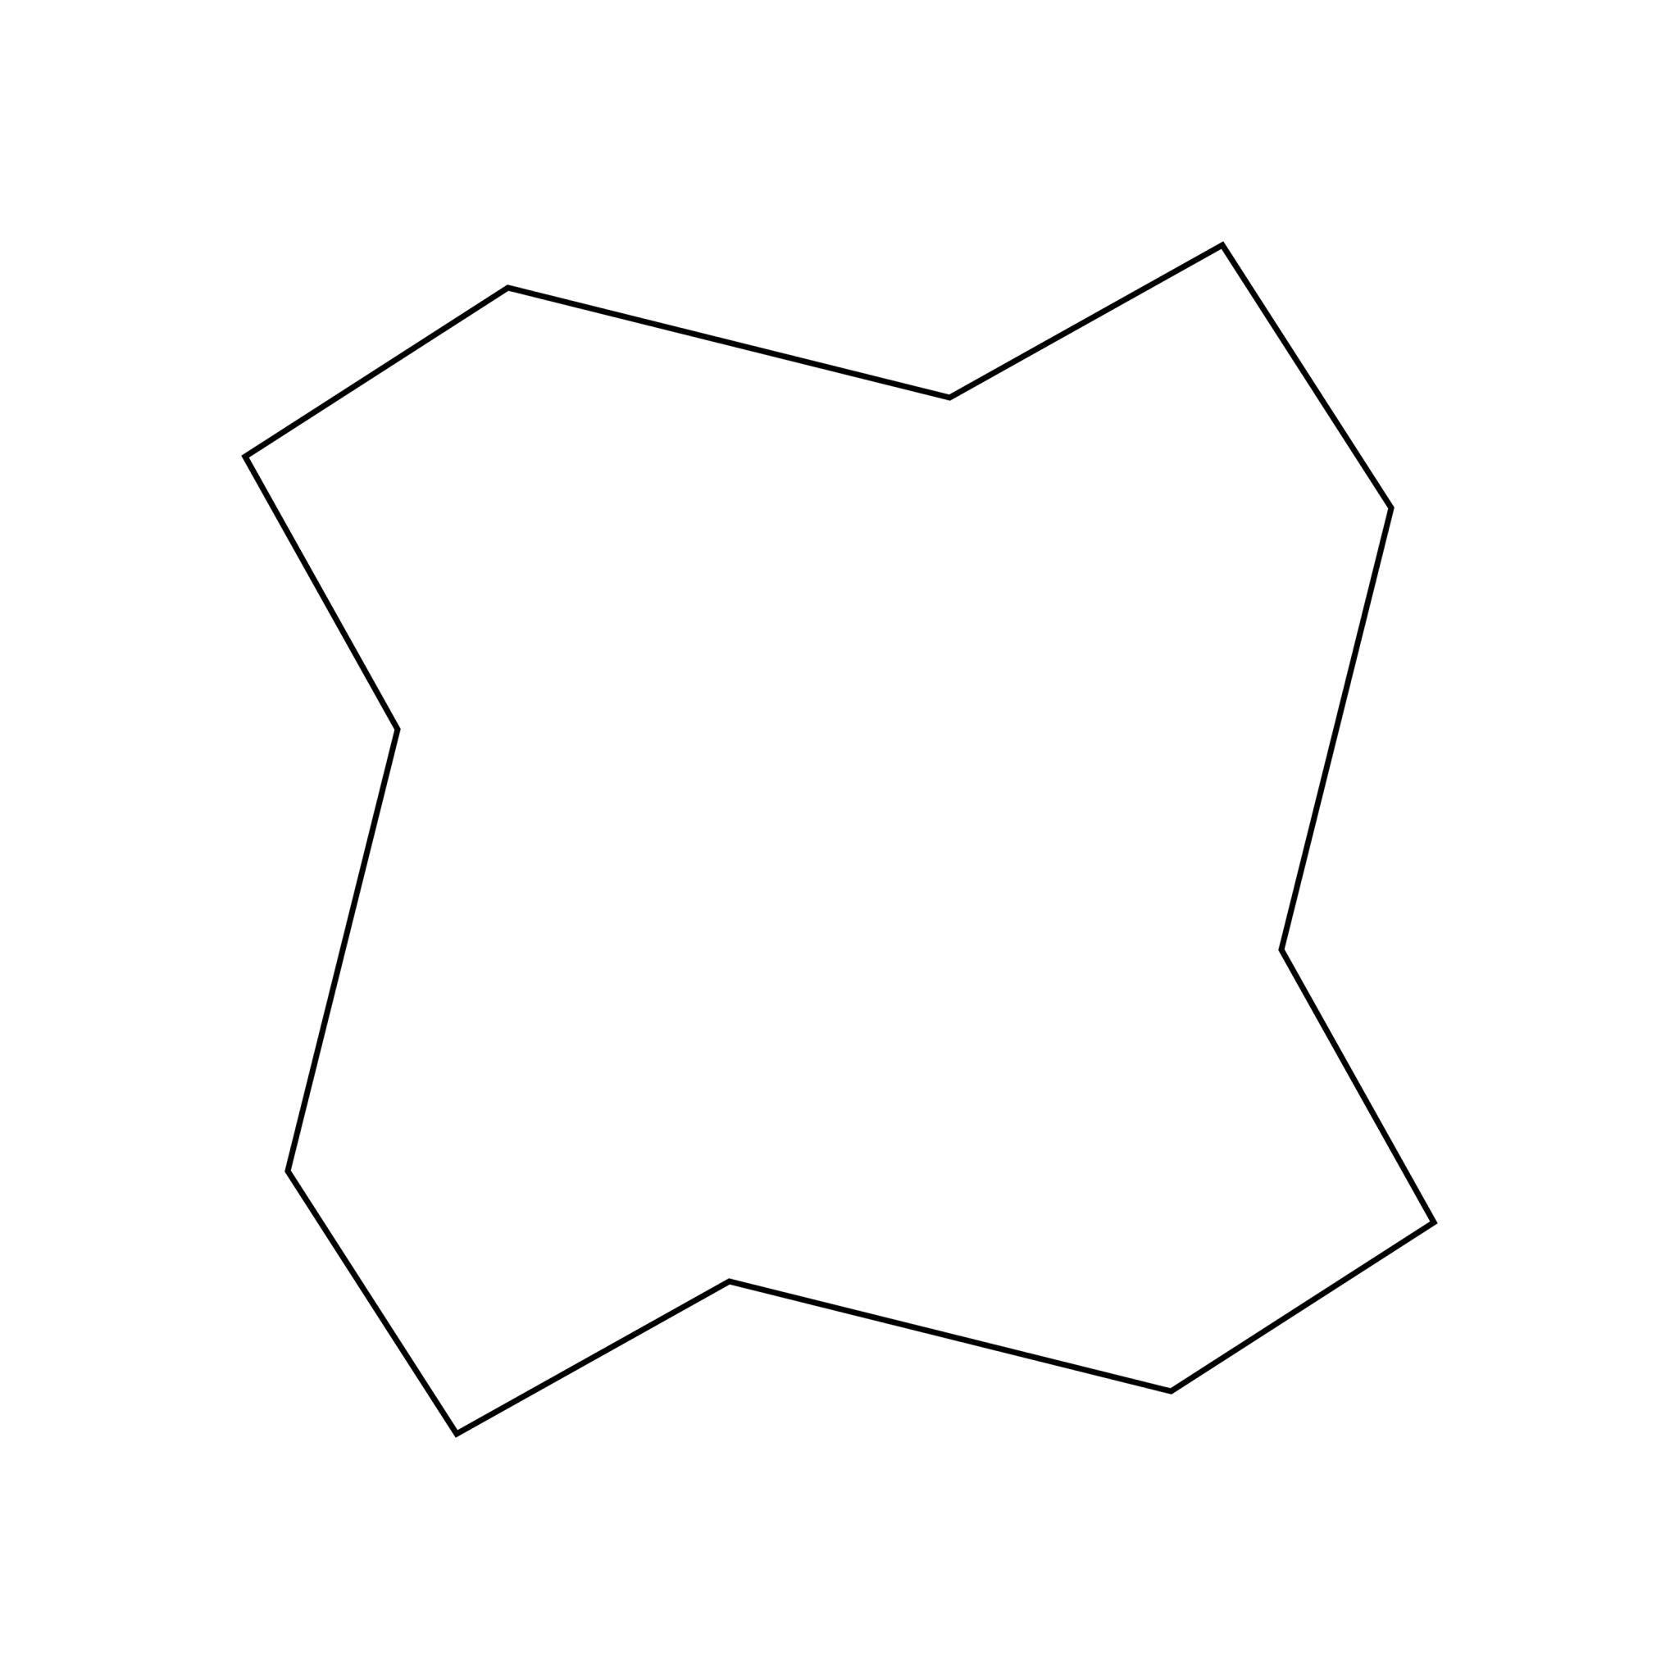
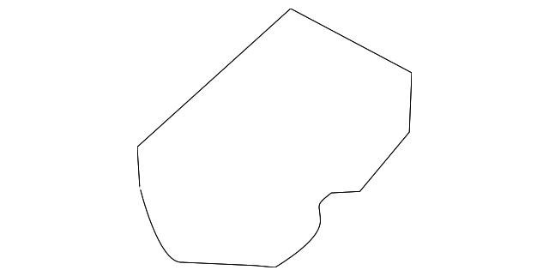
The straight and curved portions can have different lengths, directions, and curvature.

9. Symmetric Polygon–Organic Open Shape
# Source: AI Source: Provided by: [Data Path: Persons Table -> ID Column: 1, Name_En Column: Motasem Essam] -> From: [ChatGPT] on [7/25/2026]
An open mixed shape whose polygonal and organic portions are arranged around a recognizable axis of symmetry.
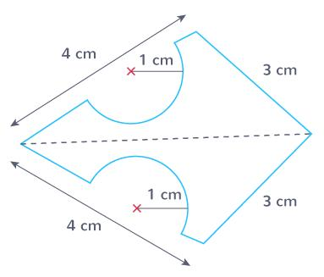

10. Freeform Polygon–Organic Open Shape
# Source: AI Source: Provided by: [Data Path: Persons Table -> ID Column: 1, Name_En Column: Motasem Essam] -> From: [ChatGPT] on [7/25/2026]
A freely designed open path combining polygonal segments and organic-looking curves.
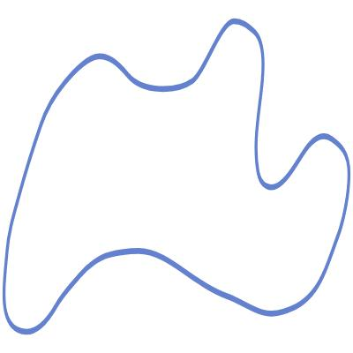
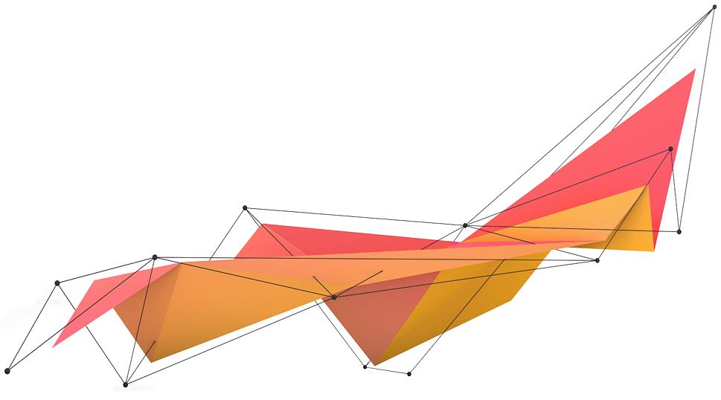
It does not follow a fixed geometric construction.

11. Multi-Curve Polygon–Organic Open Shape
# Source: AI Source: Provided by: [Data Path: Persons Table -> ID Column: 1, Name_En Column: Motasem Essam] -> From: [ChatGPT] on [7/25/2026]
An open polygonal path containing several separate organic curved sections.
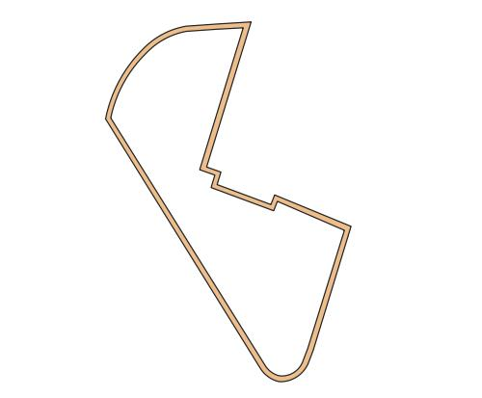
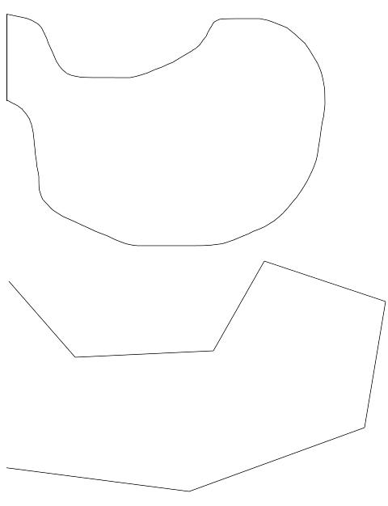
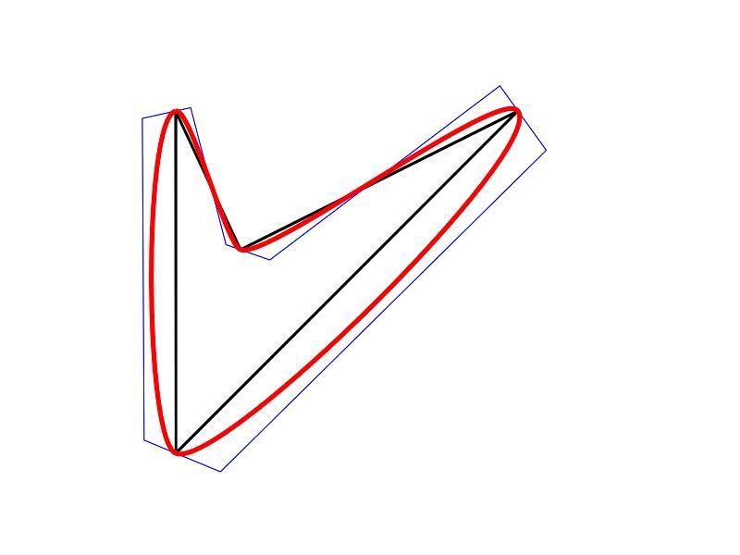

12. Complex Polygon–Organic Open Shape
# Source: AI Source: Provided by: [Data Path: Persons Table -> ID Column: 1, Name_En Column: Motasem Essam] -> From: [ChatGPT] on [7/25/2026]
A more complicated open form combining numerous straight segments with several irregular organic curves.
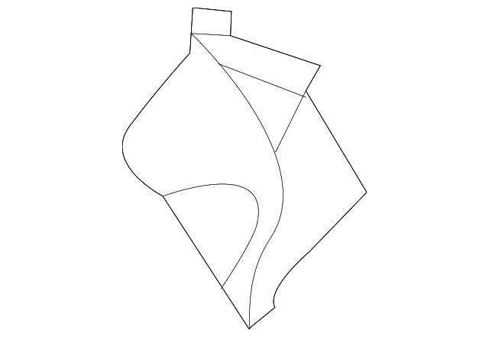

Polygon–Organic vs. Polygon–Circular Open Shapes
# Source: AI Source: Provided by: [Data Path: Persons Table -> ID Column: 1, Name_En Column: Motasem Essam] -> From: [ChatGPT] on [7/25/2026]
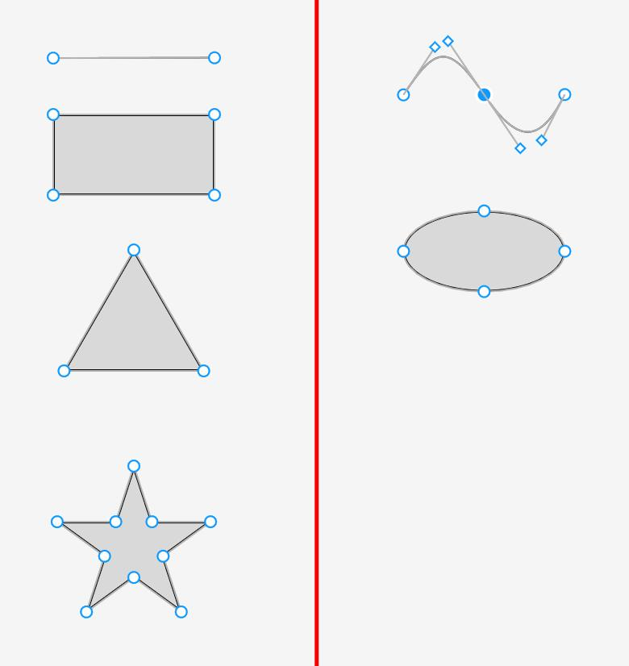
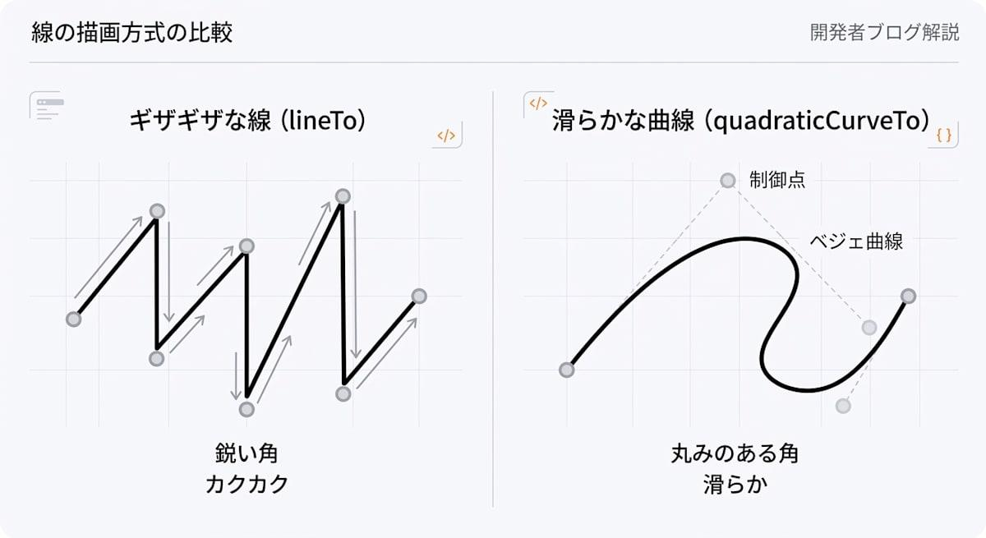
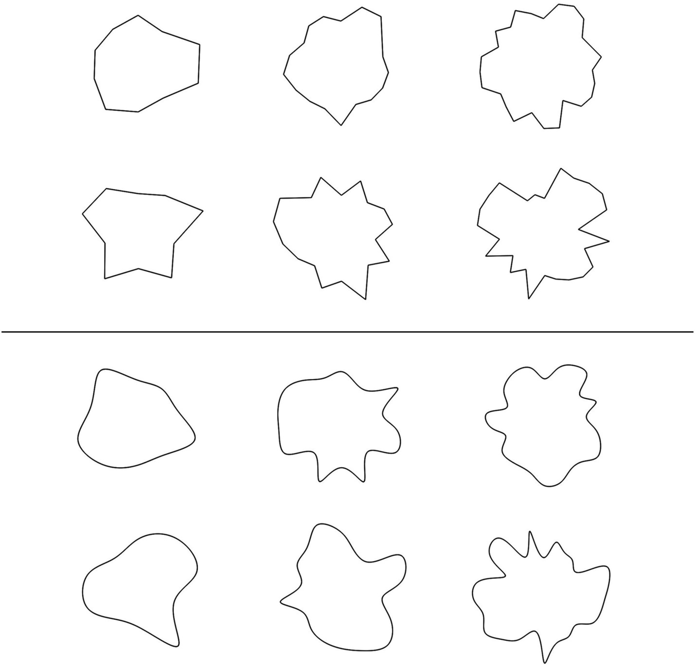
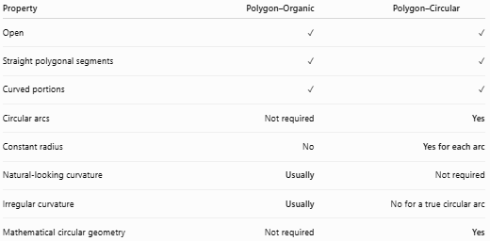
Property | Polygon–Organic | Polygon–Circular
Open | ✓ | ✓
Straight polygonal segments | ✓ | ✓
Curved portions | ✓ | ✓
Circular arcs | Not required | Yes
Constant radius | No | Yes for each arc
Natural-looking curvature | Usually | Not required
Irregular curvature | Usually | No for a true circular arc
Mathematical circular geometry | Not required | Yes
Main distinction
$$\boxed{\text{Polygon–Organic}=\text{Polygonal Segments + Natural-Looking Curves}}$$
while:
$$\boxed{\text{Polygon–Circular}=\text{Polygonal Segments + Circular Arcs}}$$

Polygon–Organic vs. Organic Open Curves
# Source: AI Source: Provided by: [Data Path: Persons Table -> ID Column: 1, Name_En Column: Motasem Essam] -> From: [ChatGPT] on [7/25/2026]
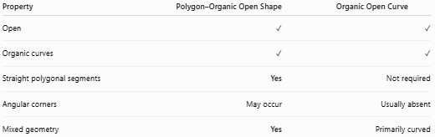
Property | Polygon–Organic Open Shape | Organic Open Curve
Open | ✓ | ✓
Organic curves | ✓ | ✓
Straight polygonal segments | Yes | Not required
Angular corners | May occur | Usually absent
Mixed geometry | Yes | Primarily curved
The polygonal component is what makes the first category a mixed shape.

Key Points
# Source: AI Source: Provided by: [Data Path: Persons Table -> ID Column: 1, Name_En Column: Motasem Essam] -> From: [ChatGPT] on [7/25/2026]
A Polygon–Organic Open Shape is:
$$\boxed{\text{Open}+\text{Polygonal}+\text{Organic}}$$
It:
- Has straight polygonal segments.
- Has organic, irregular curved portions.
- Remains open.
- Does not enclose an area by itself.
- May have sharp corners.
- May contain one or several organic curves.
- Can be natural-looking or freely designed.
- Can be symmetric or asymmetric.
- Can be simple or complex.

Conclusion
# Source: AI Source: Provided by: [Data Path: Persons Table -> ID Column: 1, Name_En Column: Motasem Essam] -> From: [ChatGPT] on [7/25/2026]
Polygon–Organic Open Shapes combine the angular structure of polygonal segments with the smooth, irregular, natural-looking character of organic curves. Their defining feature is that they contain both straight polygonal and organic curved components while remaining open.

